Out of minimum correction for the change in geometry in the CO→ NN alchemy

_ All the calculation were performed using the Horton Quantum Chemistry code, the scf calculation were done for both UHF and DFT: B3LYP levels of theory. The cc-pvTZ basis set was chosen as a good compromise between chemical accuracy and not an excessive computational cost.

STEP 0: In literature was found the vibrational absorption wave number:
- For CO was found 2143 cm-1 a rotational inference is present in the spectrum
- For NN the stretching W.N. (retrieved by raman scattering ) was at 2328.72 cm-1

From the harmonic oscillator approximation we can retrieve the vibrational angular frequencies using:
in Horton the units conversion to cm-1 can be performed by the following function:

***************************************************************************
def to_cm(k,Mu):
return (k/Mu)**0.5*centimeter/planck/lightspeed
Mu_CO=periodic['c'].mass*periodic['O'].mass/(periodic['c'].mass+periodic['O'].mass )
***************************************************************************

STEP 1 : Optimization and Calculus of the vibrational frequencies on the minimum

For both molecules (and both methods) the structure was optimized with a self-made optimization function, from the point of minimum with the second derivative was calculated with a finite differences scheme (step size 0.001 bohr).

Molecule | Method | Distance Minimum | W.N. harmonic | Hartee Energy
CO | UHF-cc-pvTZ | 2.087 | 2424.36 | -112.78181256
- | B3LYP-cc-pvTZ | 2.127 | 2229.56 | -113.35752407
NN | UHF-cc-pvTZ | 2.017 | 2731.33 | -108.98655720
- | B3LYP-cc-pvTZ | 2.063 | 2450.42 | -109.56844409
- | PBE-cc-pvTZ | 2.086 | 2359.59 | -109.446910739
- | PBE0-cc-pvTZ | 2.053 | 2523.50 | -109.4403105538

STEP2: dependence of the second derivative with respect to position.
We investigated the dependency of the second derivative with respect to the nuclear displacement. In particular in a neighborhood of the minimum we found that a displacement of .01 bohr would lead to an error of 40 cm-1 . (Fdstretching jup.notebooks)
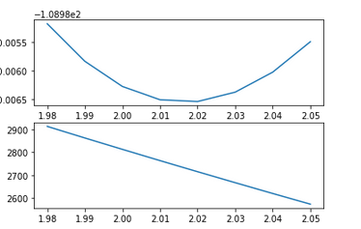
A graph for NN at B3LYP (but the behaviour is similar for CO).

The changing in the second derivative is by definition expressed by the third derivative.
In a alchemical transformation the geometry of the reference system usually differs from the geometry of the target system, thus after the alchemical transformation we need to update the geometry, the second derivative and energy of the new system starting from a fixed number of point derivatives.

STEP3: a study for higher order derivatives.

In order to make a correction for the out of minimum position, the first approach could be a Taylor expansion, thus we need to know the derivatives at least to the third order.
The shape of the derivatives for CO at the UHF level are the following:
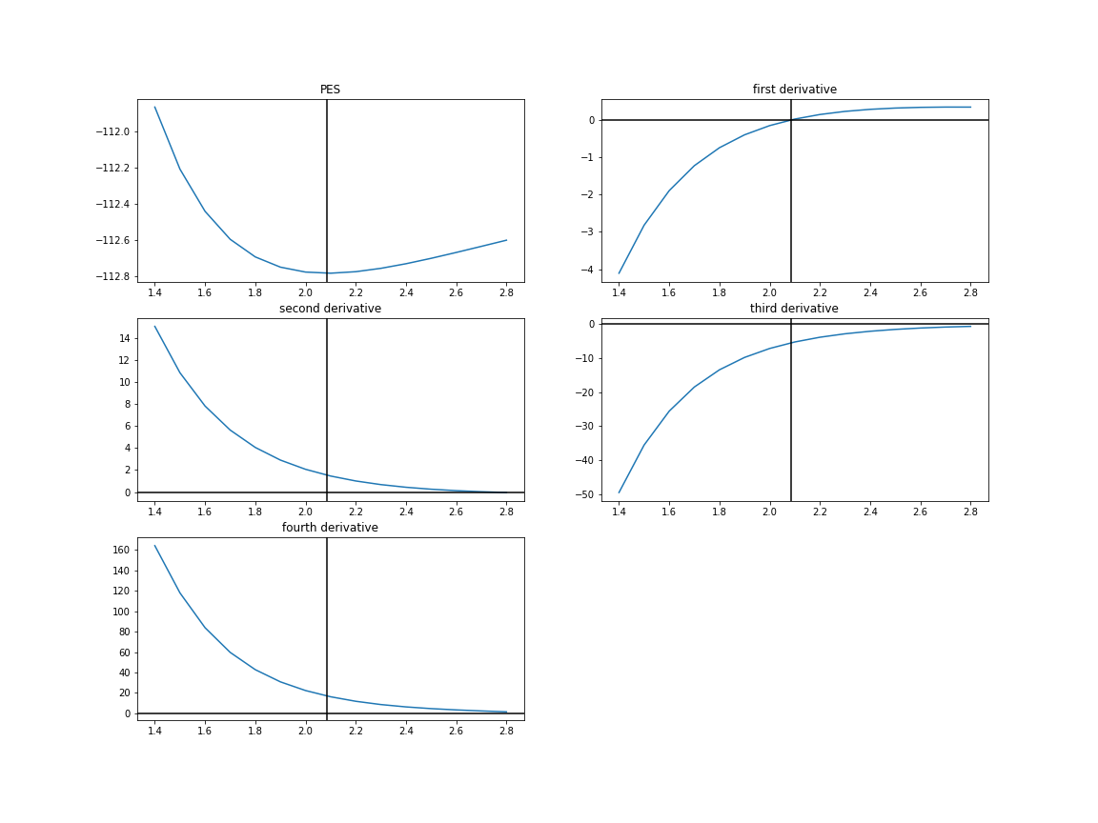
We can see that unfortunately the value of the derivatives increase by a constant factor (approx. -3.4)
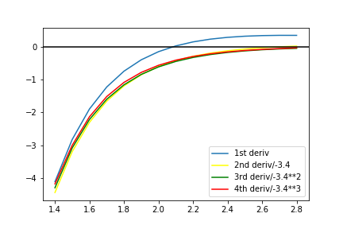
and that can be a problem for the Taylor series to converge:

Such a behavior is proper for the Morse potential:

STEP4: Updating as a Taylor series

Our purpose is now to predict the frequencies, the distance at the minimum and the minimal energies starting from the knowledge of the energy and it’s derivatives up the fourth at a point not in the minimum.

1) getting the minimum :
To correct the interatomic distance you can expand the energy as a Taylor series:

asserting that the minimum is were the first derivative is zero you can expand also the first derivative:

Depending on how many terms are considered you can get a first, a second or a third order equation in dx, that can be solved algebraically.

2) Updating the second derivatives:
After have solved for a displacement dx, you can use taylor series to correct the second derivative for not being in the minimum:

You can also update the value of the energy for not being in the minimum:

NOTE: The derivative have been evaluated by a finite difference scheme (corrected up to the 5th order)

The Python code for it:

def FivePointDerivatives(x,h):
# '''a prediction of the minimum of a function based on a 4 point approx'''
points =[]
for i in range (5):
points.append(scf(x+h*(i-2)))
fd4=(points[4]-points[3]*4+points[2]*6-points[1]*4+points[0])/h**4
fd3=(points[4]-2*points[3]+2*points[1]-points[0])/(2*h**3)
fd1=(points[3]-points[1]-h**3*fd3/3.)/2/h
fd2=(points[3]-2*points[2]+points[1]-h**4/12.*fd4)/(h**2)
return (x,points[2],fd1,fd2,fd3,fd4)
STEP5: Out of minimum corrections
The correction for not been in the minimum can be performed for different expansions for the first and the second derivative.
So we can classify the methods with respect to the order of the equation for dx we had to solve, (dx1,dx2,dx3) , and with respect to the order of expansion for f’’ (f1,f2).
Though I didn’t calculate the fifth derivative of the energy I just estimate it from the fourth derivative, assumed that the ratio of the derivative stays constant.
The Python functions for this methods is the following (the return statement are omitted)
def dx2f1(x,e,d1,d2,d3,d4):
dx=-d1/d2
p2d=d2+dx*d3
def dx2f2(x,e,d1,d2,d3,d4):
dx=-d1/d2
p2d=d2+dx*d3+dx**2*d4/2.
def dx3f1(x,e,d1,d2,d3,d4):
delta=d2**2-2.*d1*d3
if delta>0:
dx=(-d2+(delta)**0.5)/d3
p2d=d2+dx*d3
return (x+dx,to_cm(p2d))
else: return(1.,0.)
def dx3f2(x,e,d1,d2,d3,d4):
delta=d2**2-2.*d1*d3
if delta>0:
dx=(-d2+(delta)**0.5)/d3
p2d=d2+dx*d3+dx**2*d4/2.
return (x+dx,to_cm(p2d))
else: return(1.,0.)
def dx4f2(x,e,d1,d2,d3,d4):
a=d4/6.
b=d3/2.
c=d2
d=d1
D0=b**2-3*a*c
D1=2*b**3-9*a*b*c+27*a**2*d
C=((D1+(D1**2-4*D0**3)**0.5)/2.)**(1/3.)
dx=-(b+C+D0/C)/(3.*a)
p2d=d2+dx*d3+0.5*d4*dx**2
def dx4f2C(x,e,d1,d2,d3,d4):
a=d4/6.
b=d3/2.
c=d2
d=d1
D0=b**2-3*a*c
D1=2*b**3-9*a*b*c+27*a**2*d
C=((D1+(D1**2-4*D0**3)**0.5)/2.)**(1/3.)
dx=-(b+C+D0/C)/(3.*a)
p2d=d2+dx*d3+0.5*d4*dx**2+d4**2/d3*dx**3/6.
STEP6: RESULTS for out of minimum correction.

Such methods were validated for CO and N2 molecules at HF and B3LYP levels of theory.
The plot shows the update in the second derivative with respect to the reference distance :

- For the CO molecule at B3LYP level of theory
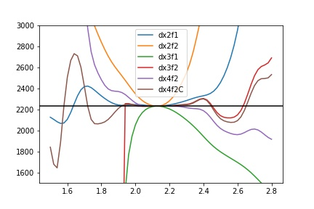
Zooming near the minimum:
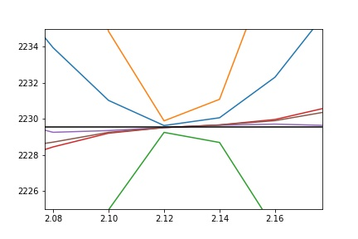
We can see that the best performance near the minimum is done by the fourth order correction in dx,
though for longer distance the correction by the 5th derivative is needed.
The dx3 method can’t give an extimate for dx for r<1.9 bohr because the delta of the second order equation is negative.

- For the NN molecule at B3LYP
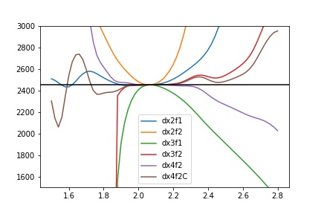

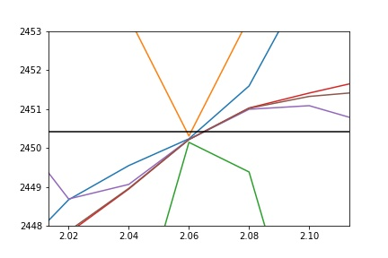

Note that this method is also useful for predicting energies and geometries of the minimum :

- For the CO molecule at B3LYP level

Energies (kj/mol scale)
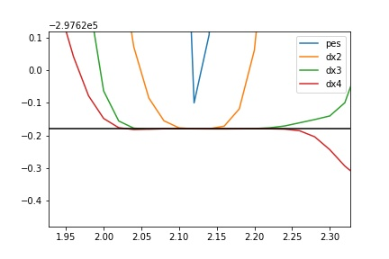
Geometries (Bohr)

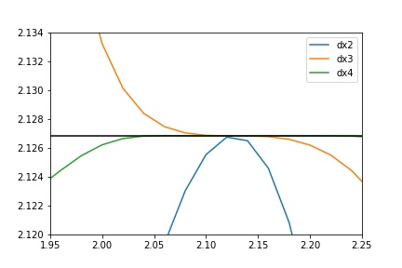

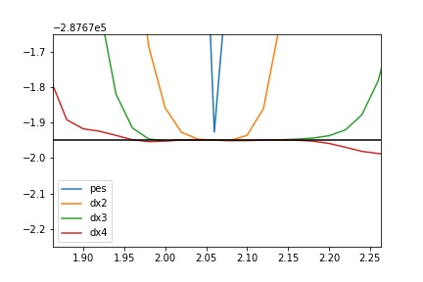
- For the NN molecule at B3LYP
Energies (kj/mol scale)

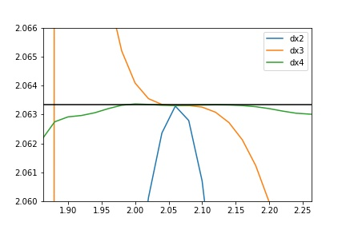
Geometries (Bohr)
ASSERTION 1 : we got good result correcting the pes with the 4th derivative, this method is valid for estimating energy, geometries and vibrational frequencies up to .2 Bohrs apart the minimum

STEP7: ALCHEMY FROM CO to N2

Then we got alchemy involved, our goal was to predict the frequency for the N2 stretching from the CO molecule. We choose a 5 point approximation (up to the 4th deriv) for the out of minimum correction, whereas for the alchemy we used a 2nd order expansion (the derivatives were obtained by a finite difference scheme with h=0.05 ) .

The vibrational frequencies obtained by alchemy on CO were confronted against the out of minimum frequency obtained by direct calculus on N2, and with the frequencies obtained by the optimized structures for other dft methods and Hartee Fock.

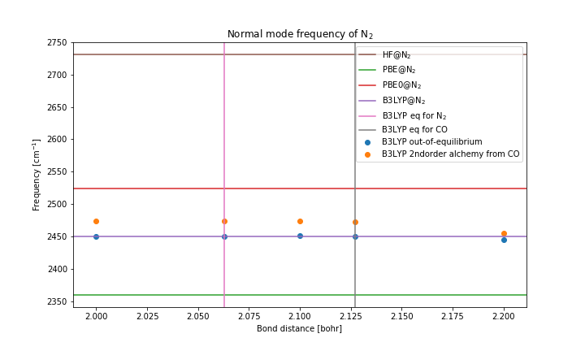
ASSERTION 2 : we showed that the alchemical estimation error for harmonic frequencies is less than the error made by changing a DFT functional.

